Exp 01. Create a simple cloud software application and provide it as a service using any
Cloud Service Provider to demonstrate Software as a Service (SaaS).

Aim
To create a simple Movie Ticket Booking cloud application using Zoho Creator and provide it as a service over the cloud to demonstrate the Software as a Service (SaaS) model.

Procedure
- Login to Zoho Creator – Open Zoho Creator and sign in using your Zoho account.
- Start a New App – Click on “Create New Application” and either pick a ready-made template or start fresh.
- Build Forms & Reports – Create forms to collect data (like user info, products, etc.) and reports to view or analyze that data.
- Add Automation – Use Deluge scripting to set rules, validations, and automatic notifications.
- Control Access – Define user roles and permissions so only the right people can view or edit certain parts.
- Publish & Share – Launch your app, get a shareable link, and let others use it online like a SaaS product.
Output
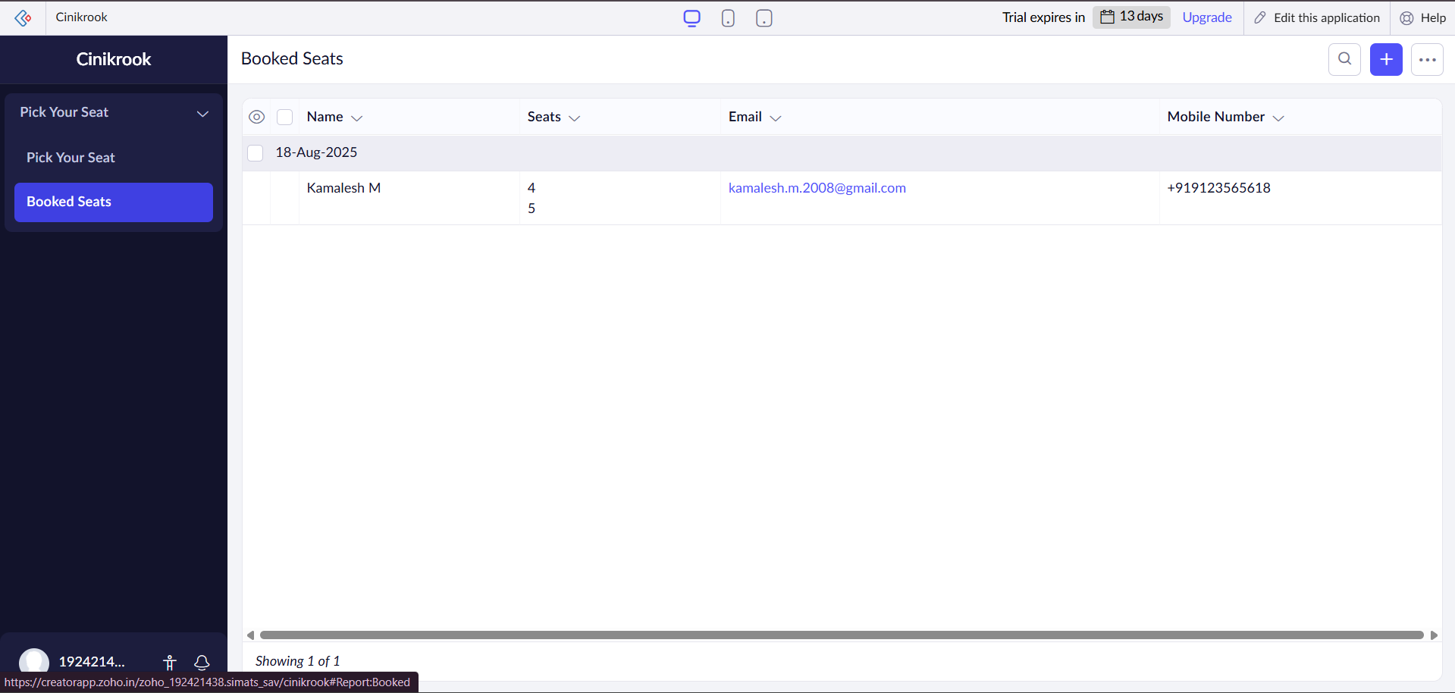

Result
Thus, a simple cloud-based application was successfully created and deployed using Zoho Creator, and it was provided as a Software as a Service (SaaS) model.

